Setting up the Voyager ArcMAP Add-in with ArcGIS Desktop

1. To set up the Voyager ArcMAP Add-in, go to the **${install.dir}/app/esri/addin** folder.

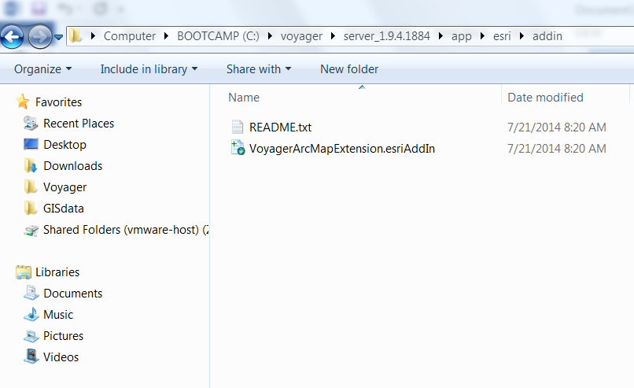

1. Copy the *VoyagerArcMapExtensionesriAddIn* file to the computer where ArcGIS Desktop is installed
2. Double-click *VoyagerArcMapExtensionesriAddIn* file and click **Install Add-in**

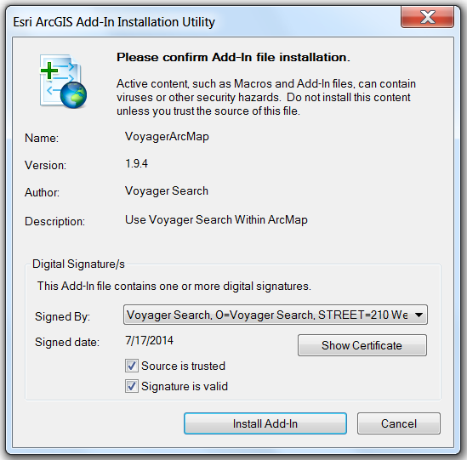

1. Open ArcMAP

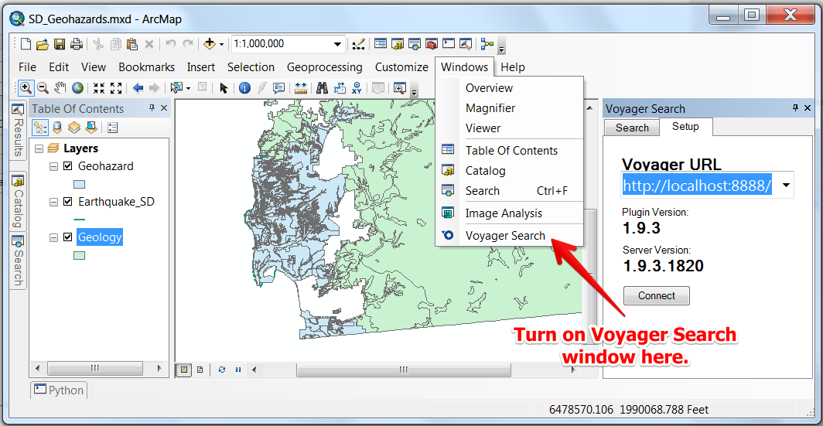

1. Select Voyager Search from the Windows menu to launch Voyager.